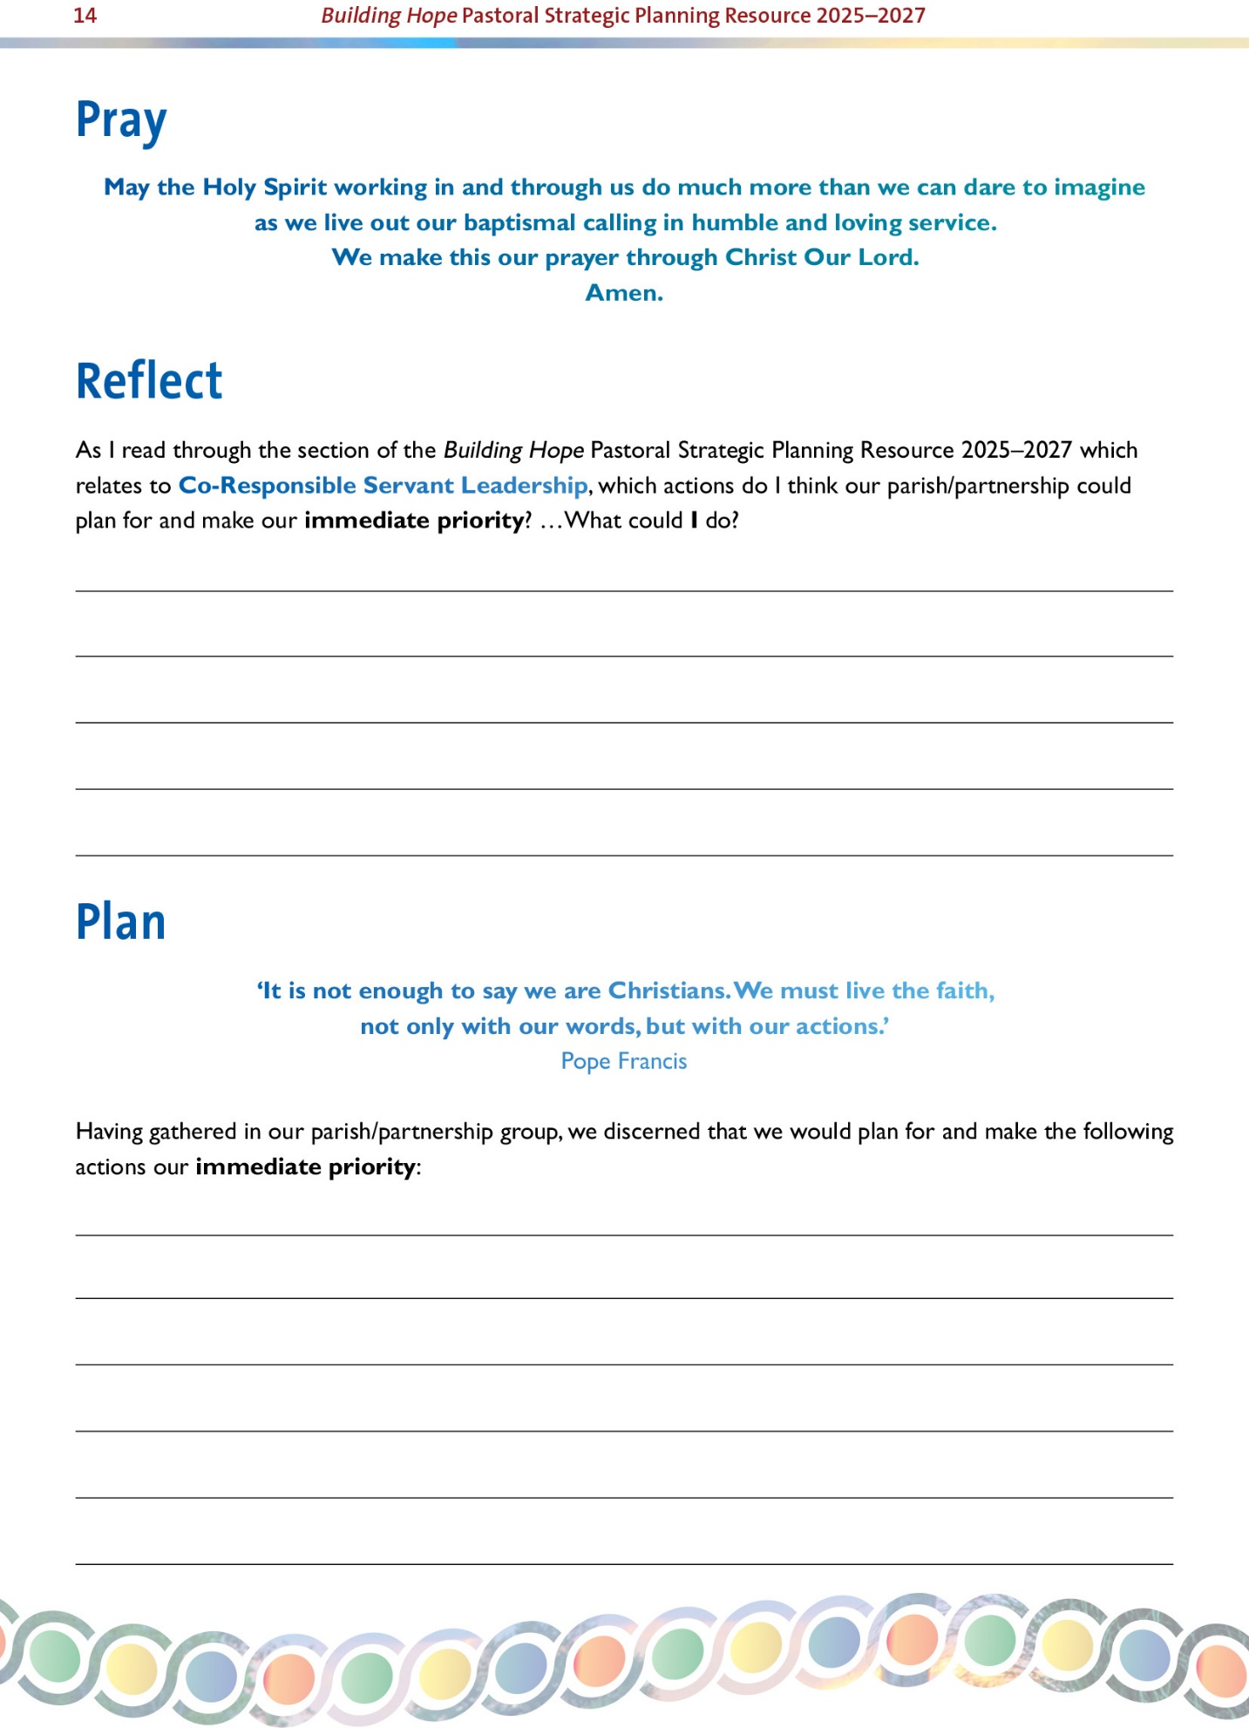

|  |  |  |  |  |  |  |  |
| --- | --- | --- | --- | --- | --- | --- | --- |
| **FOCUS AREA**  **CO-RESPONSIBLE SERVANT LEADERSHIP** | **OBJECTIVE**  **(see page 12)** | **AGREED ACTION(S)**  **(see page 13)** | **RESOURCES NEEDED TO COMPLETE ACTION [if any]** | **STEPS TOWARDS COMPLETION OF ACTION [a, b, c…]** | **NAME OF PERSON WHO WILL LEAD EACH STEP** | **TIMELINE FOR COMPLETION**  **e.g.**  **Short term - 2025**  **Medium term - 2026**  **Long term - 2027** | **REVIEW /COMMENTS** |
|  |  |  |  |  |  |  |  |
|  |  |  |  |  |  |  |  |
|  |  |  |  |  |  |  |  |
|  |  |  |  |  |  |  |  |
|  |  |  |  |  |  |  |  |
|  |  |  |  |  |  |  |  |
|  |  |  |  |  |  |  |  |
|  |  |  |  |  |  |  |  |
|  |  |  |  |  |  |  |  |
|  |  |  |  |  |  |  |  |

