World Day for Consecrated Life – 2 February 2021

‘May we come to the light that shines forever’

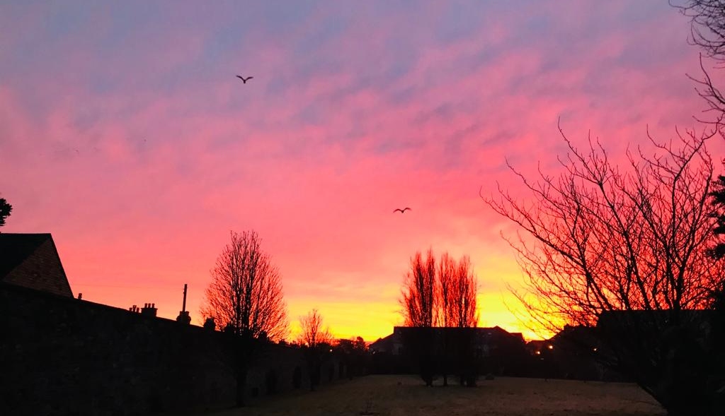
Online Service of Prayer, Music and Reflection – 8.00 p.m.

Monastery of St. Alphonsus – Drumcondra – Dublin
www.rednuns.com

